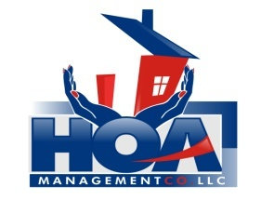
“Your community is in our hands.”

TULLS COVE HOMNEOWERS ASSOCIATION

Homeowner Information Sheet

This is general information needed by your Homeowner Association to make sure any and all correspondence is mailed to the correct address. For those of you who rent your units, contact numbers for your management company enable us to reach someone in case of an emergency.

REMEMBER: IT IS YOUR RESPONSIBILITY AS A HOMEOWNER TO KEEP YOUR CONTACT INFORMATION CURRENT.

Please take a few minutes and fill this form out. It will be filed in your personal file at our office. You may mail/drop it off to our office at 3107 Evans Street, Ste. B, Greenville, NC 27834. Or E-mail it to our Receptionist at: receptionhoa@gmail.com

Homeowner Name/Co-Owner Name: _______________________________________

Owner’s Mailing Address: _______________________________________________

Homeowner Phone Number: (H) _________________ (C) ______________________

Spouse/Co-Owner Phone Number: (H) _________________ (C) _________________

Homeowner E-Mail: ___________________________________________

Spouse/Co-Owner E-mail: ______________________________________

Emergency Contact/Number: ____________________________________

