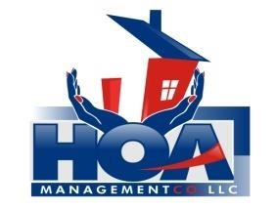

“Your community is in our hands.”
BROOKSTONE HOMEOWNERS ASSOCIATION
HOA MANAGEMENT CO., LLC
3107 Evans St. Suite B
Greenville, NC 27834

AUTHORIZATION AGREEMENT FOR DRAFTS

New Draft: __________________ Change Draft: ____________________ Stop Draft: _______________

UNIT NUMBER: __________ EFFECTIVE DATE: __________ DUES TO DRAFT: __________

I (we) hereby authorize HOA MANAGEMENT CO., LLC to draft $165.00 against my account for the payment of Brookstone Association dues on the 15th day of January and July. I understand that this authority shall remain in full force and effect until written notification is received from me of its termination in such time and in such manner as to afford the association a reasonable opportunity to act on it. If I am notified that association dues are going to increase, I understand that my draft will automatically increase at the time listed in the notice.

OWNERS NAME: ________________________________________________

MAILING ADDRESS: ________________________________________________

________________________________________________

BANK NAME: ______________________________________________________

BANK ROUTING NUMBER: _______________________________________________

CHECKING ACCOUNT NUMBER: _________________________________________

SIGNATURE: ___________________________________ DATE: _______________________

If you have any questions or concerns on the drafting of dues, please contact Linda Price, Community Manager at 252-565-4820 ext. 7 or lpricehoa@gmail.com.

VOIDED CHECK MUST BE ATTACHED

