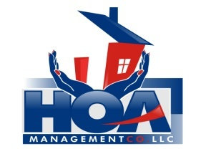
“Your community is in our hands.”

Grantham Place Homeowners Association Inc.

November 10, 2021

Greetings Grantham Place Homeowners,

We would like to welcome Grantham Place Homeowners Association and its members to HOA Management Company. Thank you for allowing us this opportunity to partner with your board to complete the daily administrative duties that are necessary to successfully run your homeowner’s association. As your management company we are available to assist you with any questions or concerns you may have. Information pertinent to your community can be found on our website www.hoamgtcompany.com. Available to you, will be options for maintenance requests, complaints, online payments, and a web page specifically for your community. Your web page will show member dues, vendors specific to your HOA, your governing documents, forms available for completion, and additional information the board chooses to post for owners to see.

Please allow us to introduce Linda Price who will be your Community Manager. She will be available to you via email at lpricehoa@gmail.com, by phone: (252) 565-4820 ext. 7, by appointment at our office, or by mail at our address: HOA Management Company, 3107 Evans Street, Ste. B, Greenville, NC 27834. Ms. Price has added your community and your personal membership to our portfolio. Included in this mailing is a copy of your member account starting balance. Please take a few moments to review it for accuracy. To ensure we have current contact information we ask you to complete the attached Homeowner Information form and return to our office.

Again, we are excited that you are a part of our HOA family. We strive to build sound, positive relationships with our members and their boards. Thank you for allowing us this opportunity to serve Grantham Place.

Sincerely,
HOA Management Company

