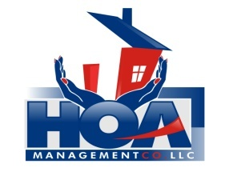
“Your community is in our hands.”

Homeowner Information Sheet

THE GATES ASSOCIATION
This is general information needed by your Homeowner Association to make sure any and all correspondence is mailed to the correct address. For those of you who rent your units, contact numbers for your management company enable us to reach someone in case of an emergency. REMEMBER: IT IS YOUR RESPONSIBILITY AS A HOMEOWNER TO KEEP YOUR CONTACT INFORMATION CURRENT.

Please take a few minutes and fill this form out. It will be filed in your personal file at our office. You may mail/drop it off to our office at 3107-B South Evans Street, Greenville, NC 27834. Or E-mail it to Beth Puryear at reception@hoamgtcompany.com

Unit #: _____________
Homeowner Name: _______________________________________
Spouse/Co-Owner Name: ___________________________________

Owner’s Mailing Address: ___________________________________

Homeowner Phone Number: (H) _________________ (C) _________________

Spouse/Co-Owner Phone Number: (H) _________________ (C) _________________

Homeowner E-Mail: ___________________________________________
Spouse/Co-Owner E-mail: ___________________________________________

Emergency Contact/Number: _________________________________

IF YOUR UNIT IS RENTED AND IS PROFESSIONALLY MANAGED PLEASE PROVIDE:
Management Company: _________________________________________________
Management Contact: ___________________________
Phone Number: ____________________ E-mail: _____________________________

