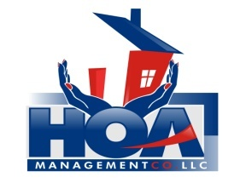
“Your community is in our hands.”

Tenant Information Sheet

SHAMROCK ASSOCIATION

If you rent your unit, please complete the following information about your tenant(s).
This form MUST be returned to:
HOA Management Company
3107-B South Evans Street, Greenville, NC 27834

Unit#: ________________

Homeowners Name & Mailing Address: __________________________________
__________________________________
__________________________________

Tenant Name(s): 1.__________________________ Phone #:________________________
2.__________________________ Phone #:________________________
3.__________________________ Phone #:________________________
4.__________________________ Phone #:________________________

Pet Information:
Pet #1 Type: ________________ Breed: ___________________ Weight: _________________

Pet #2 Type: ________________ Breed: ___________________ Weight: _________________
Pet #3 Type: ________________ Breed: ___________________ Weight: _________________

Please make sure to give all tenants a copy of the association by-laws and rules/regulations. Should the tenant fail to abide by said documents, the individual homeowner will be held responsible.

________________________________ __________________
Signature of Homeowner Date

________________________________ __________________
Signature of Rental Agent (if applicable) Date

