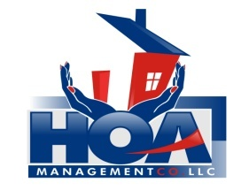
“Your community is in our hands.”

Tenant Information Sheet

COVENGTON SQUARE ASSOCIATION
If you rent your unit, please complete the following information about your tenant(s).
This form MUST be returned to:
HOA Management Company
3107-B South Evans Street, Greenville, NC 27834

Unit#: ________________

Homeowners Name & Mailing Address: __________________________________
__________________________________
__________________________________

Tenant Name(s): 1.__________________________ Phone #:________________________
2.__________________________ Phone #:________________________
3.__________________________ Phone #:________________________
4.__________________________ Phone #:________________________

Pet Information:
Pet #1 Type: ________________ Breed: ___________________ Weight: _________________

Pet #2 Type: ________________ Breed: ___________________ Weight: _________________
Pet #3 Type: ________________ Breed: ___________________ Weight: _________________

Please make sure to give all tenants a copy of the association by-laws and rules/regulations. Should the tenant fail to abide by said documents, the individual homeowner will be held responsible.

________________________________ __________________
Signature of Homeowner Date

________________________________ __________________
Signature of Rental Agent (if applicable) Date

